AWS DOMAIN SERVICES

1. We need to have a registerded domain.

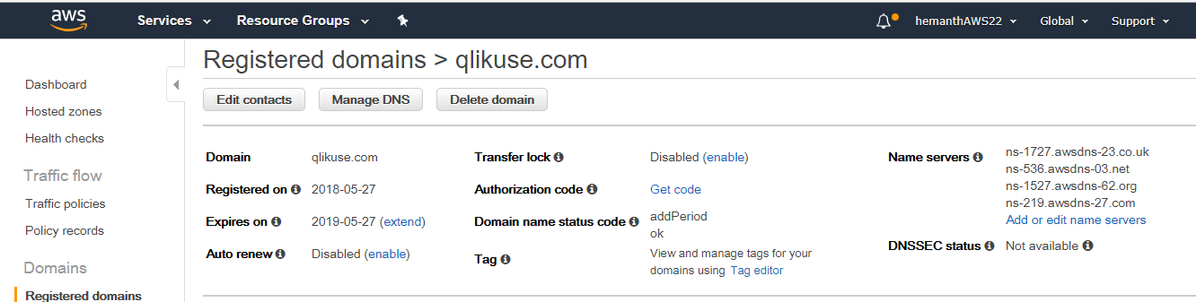

1. Create a Hosted Zone

A hosted zone tells Route 53 how to respond to DNS queries for a domain such as example.com.

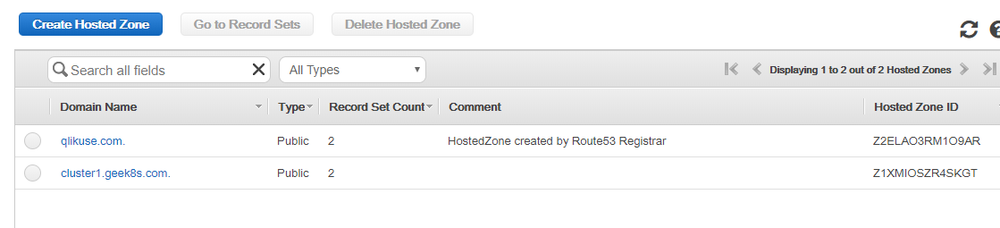

AWS Domain automatically creates a hosted zone with NS in it.

Next create cluster:

kops create cluster --name=dev.qlikuse.com --state=s3://cluster5.k8s.appychip.vpc --zones=eu-west-1a --node-count=1 --node-size=t2.micro --master-size=t2.micro --dns-zone=qlikuse.com

USING OTHER DOMAIN SERVICES LIKE NAME CHEAP:

NOTE: IT MAY TAKE UPTO 24 HOURS FOR NS CREATED IN HOSTED ZONE TO BE VERFIED.

CHECK USING: dig NS qlikuse.com or dig NS geek8s.com

1. Create a domain

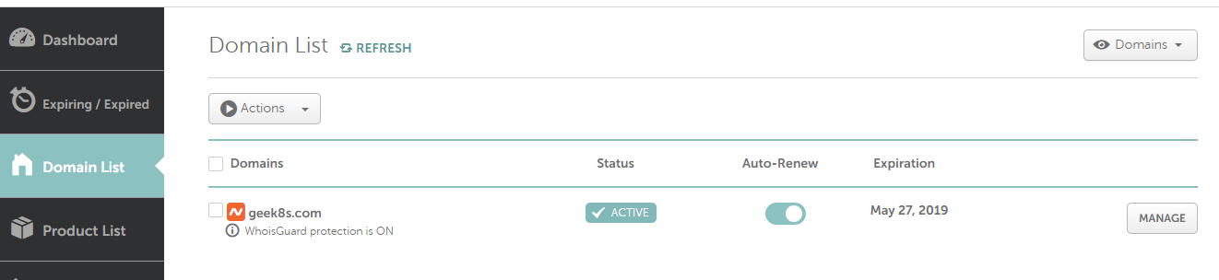

1. Next create hosted zone in AWS and copy the NS server details.
2. In Name Cheap go to manage and then advanced DNS, add the NS created in AWS hosted zone.

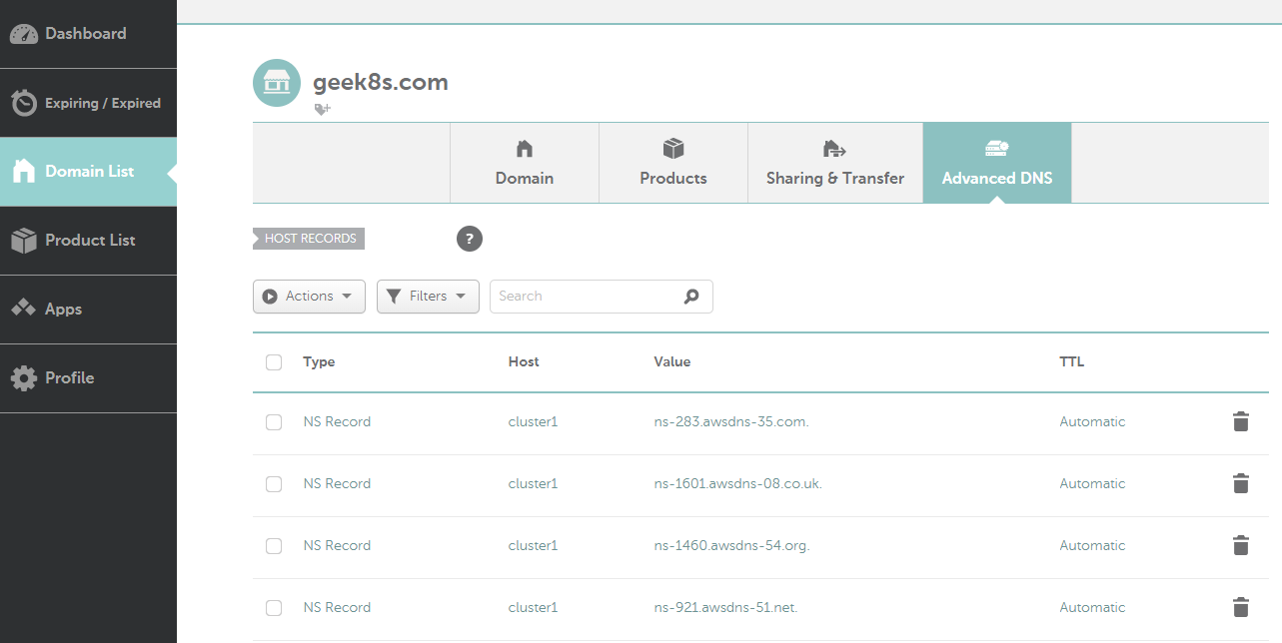

NOTE: IT MAY TAKE UPTO 24 HOURS FOR NS CREATED IN HOSTED ZONE TO BE VERFIED.

CHECK USING: dig NS qlikuse.com or dig NS geek8s.com